

BW16 Specification
Version |  | V1.2.2
Copyright |  | ©2024
Document resume
Version | Date | Develop/revise content | Edition | Approve
V0.9 | 2019.06.15 | Initial release | Yang Xiaofei | Hong Xu
V1.0 | 2019.10.29 | Updated | Xie Yiji | Hong Xu
V1.1 | 2021.02.05 | Updated flash | Xie Yiji | Hong Xu
V1.2 | 2023.08.30 | Updated temperature picture | Li xiaocheng | Hong Xu
V1.2.1 | 2024.03.25 | Updated Power Requirements  Updated Shield Pattern  Add USB Differential Pair Signal Description | Xiangfei Zeng | Hong Xu
V1.2.2 | 2024.07.25 | Fixed up Pin Definition | Xiangfei Zeng | Hong Xu
Content
1. Product Overview 4
1.1. Features 5
2. Main Parameters 6
2.1. Electrical parameter 6
2.2. Electrical parameter 7
2.3. Wi-Fi Radio Performance 7
2.4. BLE Radio Performance 8
3. Appearance & Package 9
4. Pin Definitions 10
5. Schematic 12
6. Design Guideline 13
6.1. Application Circuit 13
6.2. Recommend PCB Package 13
6.3. Antenna Layout Requirements 14
6.4. Power Supply Requirements 14
6.5. GPIO 15
7. ROLLING OF Reflow soldering 16
8. ROLLING OF Reflow soldering 16
9. Package Information 16
10. Contact us 17
Disclaimer and copyright notice 18
Notice 18
Statement 19

Product Overview
BW16 is a dual-frequency Wi-Fi Bluetooth SoC module based on RTL8720DN. BW16 supports dual-frequency (2.4ghz or 5ghz) WLAN and low-power Bluetooth 5.0; it integrates ARM V8 (compatible with Cortex-M4F) high-performance MCU,ARM V8M (compatible with Cortex-M0) low-power MCU,WLAN(802.11 a / b / g / n), MAC, Bluetooth baseband and RF baseband) and provides a set of configurable GPIO ports for the control of different peripherals.
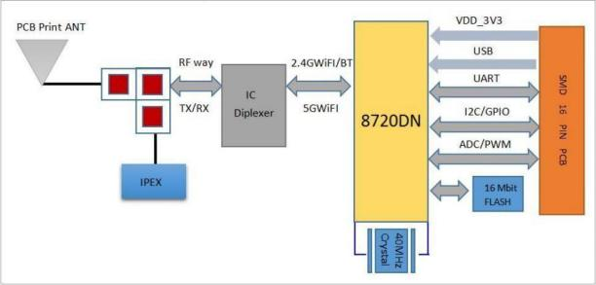Figure 1 Main chip architecture diagram

Features
- Support for either 802.11a/b/g/n, 2.4GHz or 5GHz
- Supports the HT 20 / HT 40 mode
- Supports low power beacon listening mode, low power receiving mode and low power hanging mode
- Built-in AES / DES / SHA hardware engine
- Support TrustZone-M and support safe startup
- Supports the SWD debug port access protection and disabled modes
- Support for BLE 5.0
- Bluetooth supports high-power mode (7 dBm, sharing the same PA with Wi-Fi)
- Wi-Fi and Bluetooth share the same antenna
- Support the STA / AP / STA + AP mode and confounding mode
- Support for Android, iOS Simple Config (App) Wi-Fi one-click distribution network
- Support for Bluetooth auxiliary distribution network
- Support for serial port local upgrade and remote firmware upgrade (FOTA)
- Support secondary development, support programming in Linux and Windows environments
- Support for Arduino development

Main Parameters
Table 1 Main Parameter
Model | BW16
Package | SMD-16
Dimension | 24*16*3(±0.2)MM
Antenna | On-Board PCB Antenna / I-PEX
Frequency | 2400~2483.5MHz & 5180~5825MHz
Operating Temperature | -40 ℃~85 ℃
Store Temperature | -40 ℃~125 ℃，<90%RH
Power Supply Voltage | 3.0V~3.6V, I>500mA
Interface | UART/GPIO/ADC/PWM/IIC/SPI/IR/SWD/USB
Available GPIO | 13
UART Baudrates | 110~ 6000000 bps，Default 115200bps
Bluetooth | BLE 5.0 without BR/EDR
Wireless Security | WAPI, WEP, WPA/WPA2/WPA3-PSK, WPA/WPA2/WPA3-EAP
SPI Flash | Default 4MB (Optional 2MB, 8MB, 16MB)

Electrical parameter
BW16 module is an electrostatic sensitive device, which needs special ES precautions.When usd ESD protective devices should be added. The correct ESD processing and packaging must be adopted in the transportation, operation and use of BW16 modules. Do nottouch the module by hand or weld with a non-antistatic soldering iron to avoid damage to the module.

Figure 2 ESD Warning Logo

Electrical parameter
Table 2 Electric Characteristic
Parameter | Min | Typical | Max | Unit
DC 3.3V (with internal regulator and integration CMOS PA) | 3.0 | 3.3 | 3.6 | V
Figure I/O supply voltage | 1.76 | 1.8~3.3 | 3.3 | V
DC_IO_33 (3.3V I / O rated current) | - | - | 50 | mA
Electrostatic protection (VESD) | - | - | 2000 | V

Wi-Fi Radio Performance
Description | Typical |  |  | Unit
Operating Frequency | 2400~2483.5 and 5180~5825 |  |  | MHz
Output Power
Mode | Min | Typical | Max | Unit
11a mode，PA output power | 12 | 14 | 16 | dBm
11n mode，PA output power | 12 | 14 | 16 | dBm
11g mode，PA output power | 13 | 15 | 17 | dBm
11b mode，PA output power | 14 | 16 | 18 | dBm
Rx Sensitivity
Mode | Min | Typical | Max | Unit
CCK，1Mbps | - | ≤-90 | - | dBm
CCK，11Mbps | - | ≤-85 | - | dBm
6Mbps（1/2 BPSK） | - | ≤-88 | - | dBm
54Mbps（3/4 64-QAM） | - | ≤-70 | - | dBm
HT20（MCS7） | - | ≤-67 | - | dBm
Table 3 Wi-Fi Radio Performance

BLE Radio Performance
表4 BLE Radio Performance
Description | Typical |  |  |  | Unit
Operating Frequency | 2400 ~ 2483.5MHz |  |  |  | MHz
Output Power
Mode | Min | Typical | Max |  | Unit
1Mbps | 5 | 7 |  | 9 | dBm
2Mbps | 5 | 7 |  | 9 | dBm
Rx Sensitivity
Mode | Min | Typical | Max |  | Unit
1Mbps @30.8%PER | - | -92 |  | - | dBm
2Mbps @30.8%PER | - | -92 |  | - | dBm

Appearance & Package
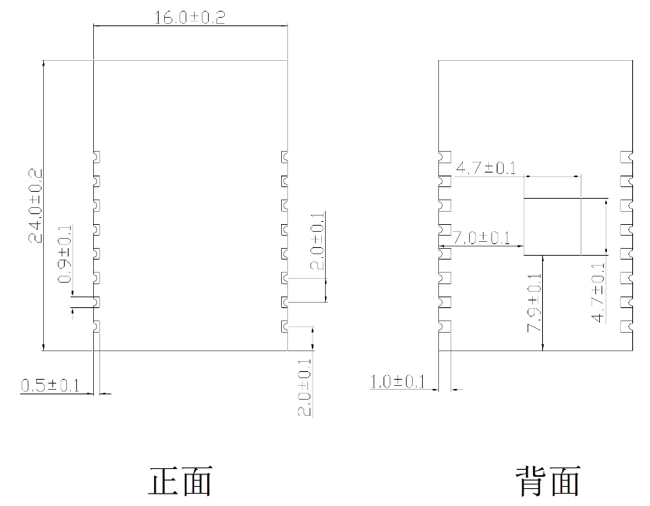
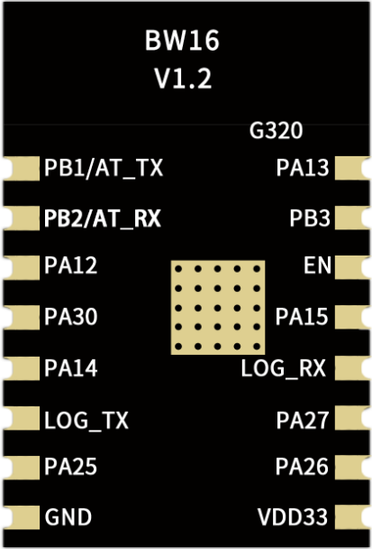
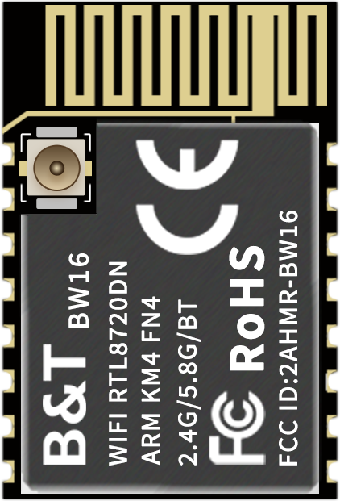
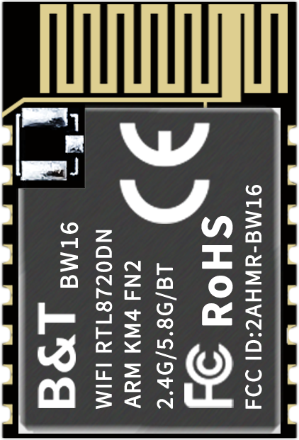
Figure 3 Appearance
Front
Back
Back
Front
Front
Figure 4 Package

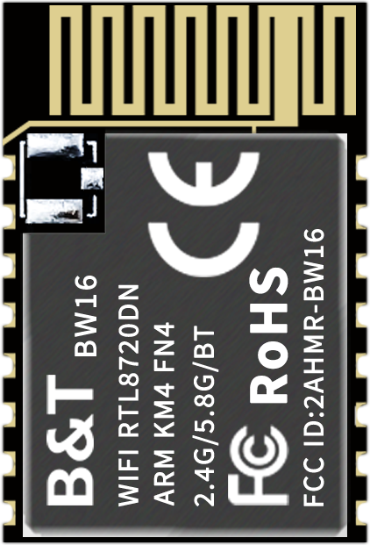
U: Support for the USB interface
x: FLASH Size (MB)
H/N: Operating Temperature
H: High Temp N: Normal

F: FLASH
Figure 5 Order Information支持USB接口

Pin Definitions
BW16 has 16 interface，refer to following Pin diagram ，Table 2.2 is definition of interfaces.
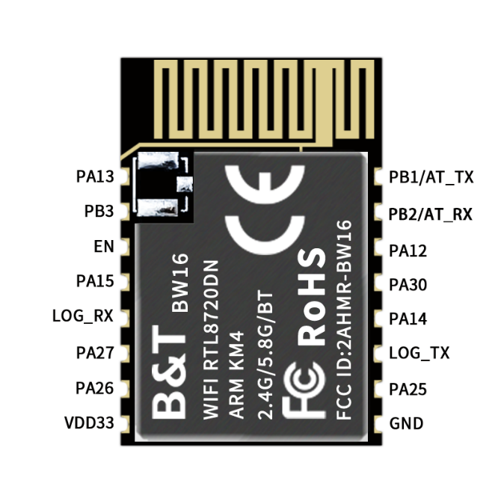
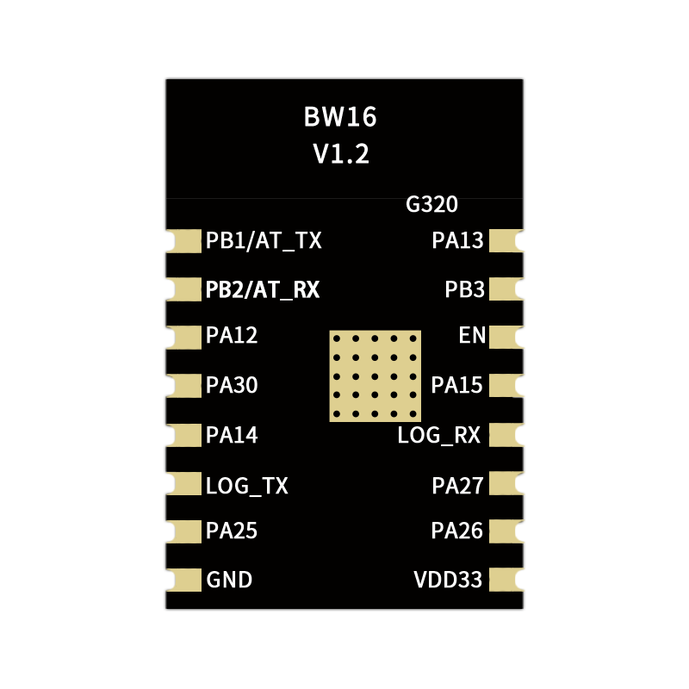
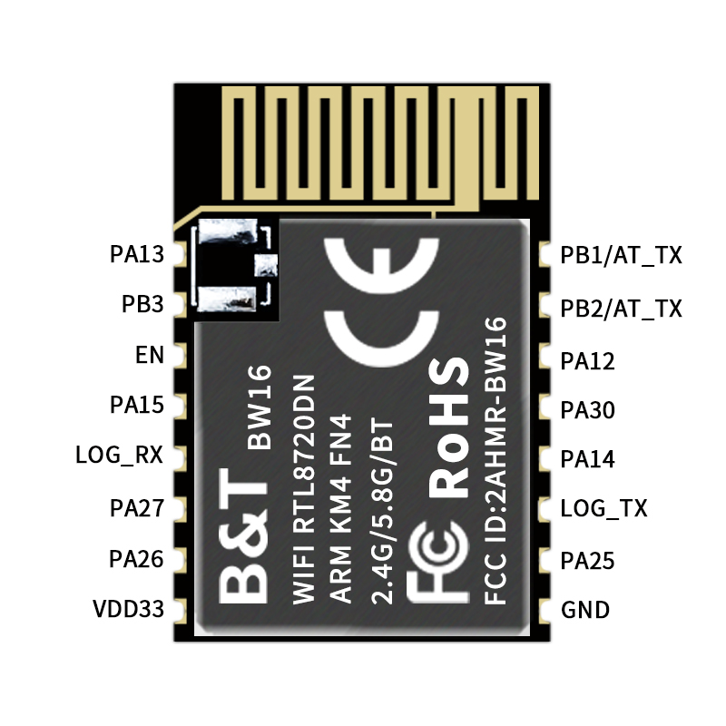Figure 6 Pin out Diagram
Front
Back
Table 5 Pin definitions
No | Name | Description
1 | PA13 | LP_PWM1/SPI1_MISO
2 | PB3 | ADC/SWD_CLK
3 | CHIP_EN | Chip Enabled
4 | PA15 | SPI1_CS
5 | PA8 | UART_LOG_RXD
6 | PA27 | SWD_DATA
7 | PA26 | LP_I2C_SDA/LP_PWM5
8 | VDD_3V3 | 3.3V（VDD）
9 | GND | Ground
10 | PA25 | LP_I2C_SCL/LP_PWM4/HSDM
11 | PA7 | UART_LOG_TXD
12 | PA14 | SPI1 CLK
13 | PA30 | LP_PWM1
14 | PA12 | SPI1_MOSI/LP_PWM0
15 | PB2 | LP_UART_RXD
16 | PB1 | LP_UART_TXD
Note: 1. When the LOG _ TX moment is low, the module enters the burning mode; When the moment is high, the module starts normally and the internal pull up by default.

Schematic
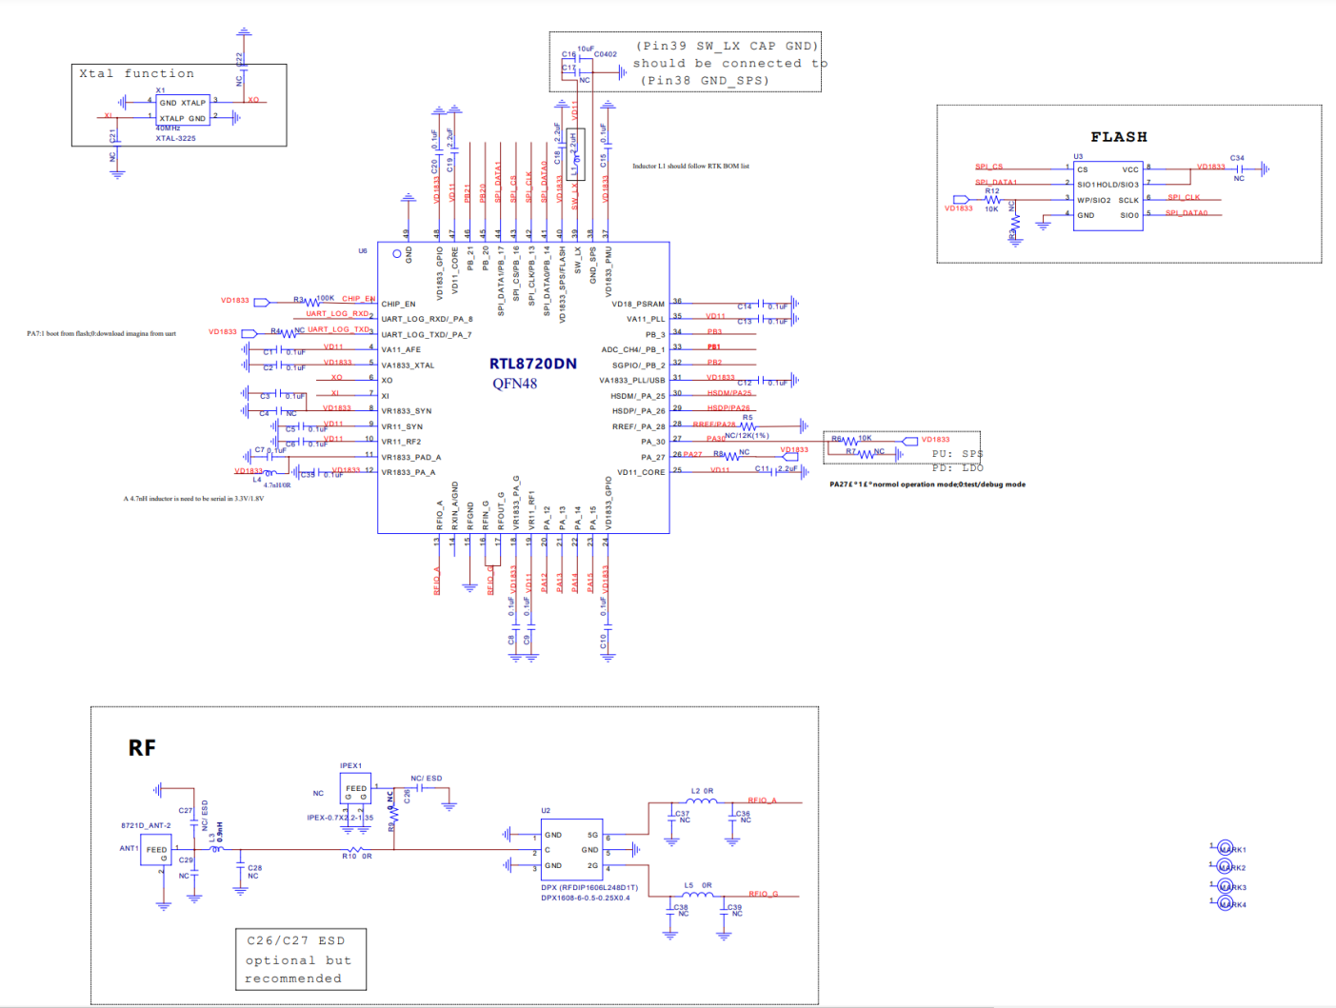Figure7 Schematic

Design Guideline

Application Circuit
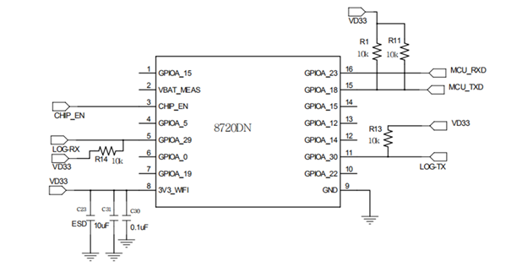
Figure 8 Application Circuit
Note:
- LOG _ TX is the starting control foot in normal operating mode at high level and burning firmware mode at low level. Internal chip default high level.

Recommend PCB Package
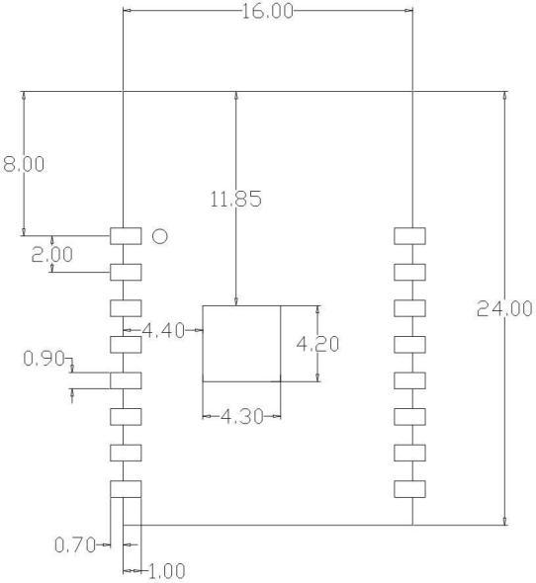
Figure 9 Recommend PCB Package

Antenna Layout Requirements
- Installation position on the main board，advise for following two ways:
- The module is placed on the edge of the main board, and the antenna area is extended out of the edge of the main board. 2.In order to meet the performance of the on-board antenna, metal parts are prohibited from being placed around the antenna.
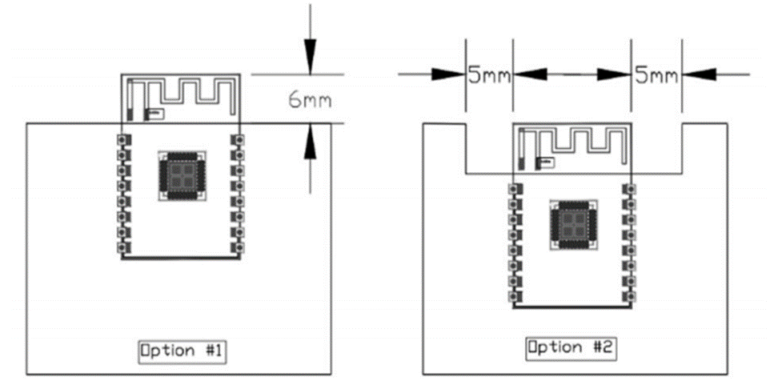
Figure 10 Schematic diagram of Antenna layout

Power Supply Requirements
- Recommended voltage 5V, Peak:Current over 500mA .
- It is recommended to use the LDO power supply；If DC-DC is used, the ripple is controlled within 30 mV.
- DC-DC power supply circuit is recommended to reserve the position of the dynamic response capacitor, and the output ripple can be optimized when the load change is large.
- Proposed addition of ESD Devices to 5V Power supply Interface.
- For 3.3V application, if the power up slew rate from 1.5V to 3.0V is slower than 15ms, The wide range VCC Flash is needed or add reset IC.
- In the process of power off to power on, if the power off voltage can't be guaranteed to drop below 0.3v and power on again, reset IC should be added.
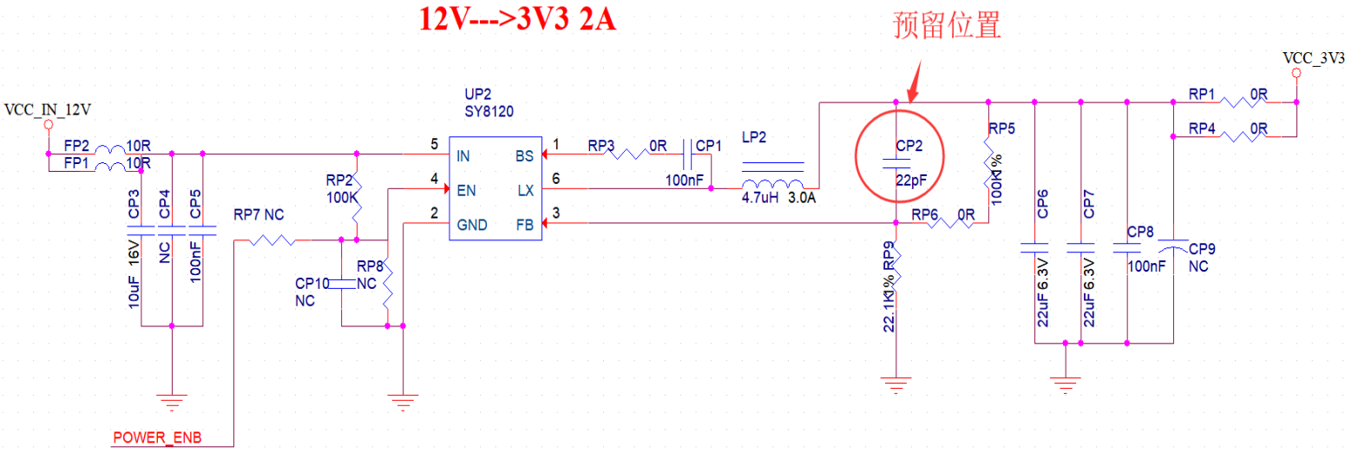
Figure10 DC-DC Buck Circuit

GPIO
- At the periphery of the module, some GPIO ports are led out, and a resistance of 10-100 ohms can be connected in series on the IO port for use. This suppresses overshoot and is more stable on both sides. Help for both EMI and ESD.
- For the up-and-down drawing of the special io-port, reference will be made to the use description of the specification, which will affect the start-up configuration of the module.
- The IO port of the module is 3.3 v. If the main control does not match the io-level of the module, it is necessary to increase the level conversion circuit.
- If the IO interface is directly connected to the peripheral interface, or the pins and other terminals, it is recommended to reserve the ESD device near the terminal at the IO trace.
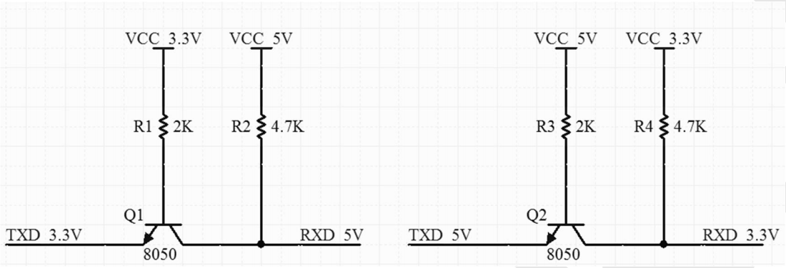
Figure 11 switching circuit

ROLLING OF Reflow soldering
Products sealed in a moisture-proof bag shall be stored in a non-condensing atmosphere of <40℃ / 90% RH.
The moisture sensitivity grade MSL of the module is level 3.
After the vacuum bag is unsealed, it must be used within 168 hours at 25 ± 5℃ / 60% RH, otherwise it needs to be baked before the secondary launch.

ROLLING OF Reflow soldering
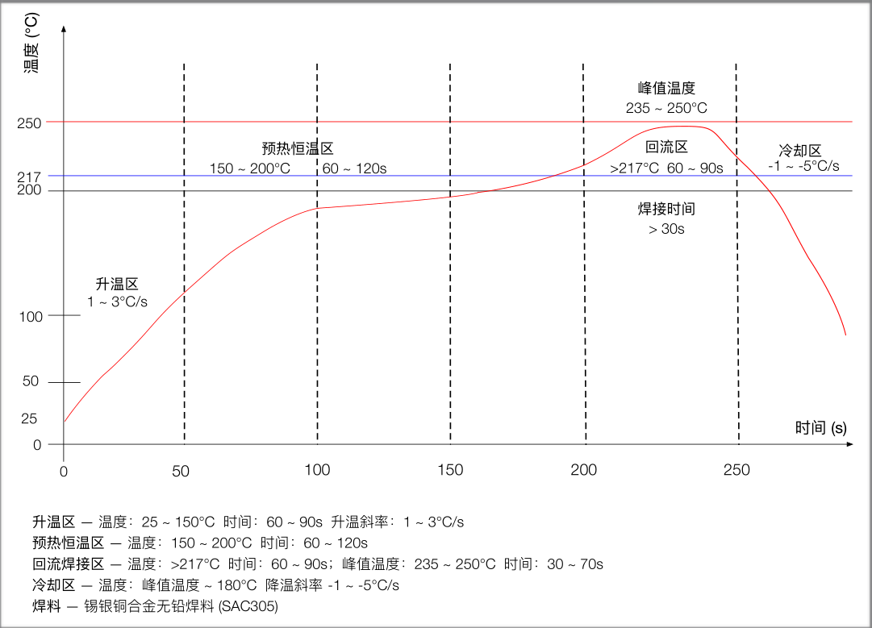
Figure12 ROLLING OF Reflow soldering

Package Information

BW16 module is packaged with 800 pcs / disk. As shown in the figure below:
Figure 13 packing ribbon diagram

Contact us
Ai-Thinker official website Official Forum Develop DOCS LinkedIn Tmall shop Taobao shop Alibaba shop
Technical support Email: support@aithinker.com
Domestic business cooperation: sales@aithinker.com
Overseas business cooperation：overseas@aithinker.com
Company address: Room 403-405,408-410, Block C, Huafeng Smart Innovation Port, Gushu 2nd Road, Xixiang, Baoan District, Shenzhen.
Tel: 0755-29162996


WeChat mini

WeChat official

Disclaimer and copyright notice
The information in this article, including the URL address for reference, is subject to change without notice.
The document is provided "as is" without any guarantee responsibility, including any guarantee for merchantability, suitability for a specific purpose, or non-infringement, and any guarantee mentioned elsewhere in any proposal, specification or sample. This document does not bear any responsibility, including the responsibility for infringement of any patent rights arising from the use of the information in this document. This document does not grant any license for the use of intellectual property rights in estoppel or other ways, whether express or implied.
The test data obtained in the article are all obtained from Ai-Thinker's laboratory tests, and the actual results may vary slightly.
All brand names, trademarks and registered trademarks mentioned in this article are the property of their respective owners, and it is hereby declared.
The final interpretation right belongs to Shenzhen Ai-Thinker Technology Co., Ltd.

Notice
Due to product version upgrades or other reasons, the contents of this manual may be changed.
Shenzhen Ai-Thinker Technology Co., Ltd. reserves the right to modify the contents of this manual without any notice or prompt.
This manual is only used as a guide. Shenzhen Ai-Thinker Technology Co., Ltd. makes every effort to provide accurate information in this manual. However, Shenzhen Ai-Thinker Technology Co., Ltd. does not guarantee that the contents of the manual are completely free of errors. All statements and information in this manual. And the suggestion does not constitute any express or implied guarantee.

Statement
ormation and other resources (the "Resources") "as is" without warranties of any kind, express or implied. Including, but not limited to, express or implied warranties of suitability, fitness for a particular use, or non-infringement of any third party's intellectual property rights.And specifically declares that it is not liable for any necessary or incidental losses, including but not limited to, arising from the application or the use of any of our products and circuits.
Ai-Thinker reserves the right to release information in this document (including but not limited to metrics and product descriptions) and any changes to our products without prior notice. This document automatically supersedes and replaces all information provided in previous versions of the same document number file.
These resources are available to skilled developers who design with Ai-Thinker products. You are solely responsible for: (1) Selecting the appropriate Ai-Thinker products for your application; (2) Design, validate, and run your application and product throughout its life cycle; (3) Ensure that your application meets all applicable standards, codes and laws, as well as any other functional security, information security, regulatory or other requirements.
Ai-Thinker may authorize you to use these resources only for the development of applications of Essence Products described in this Resource. Without the permission of Ai-Thinker, any unit or individual shall not extract or copy part or all of these resources, and shall not be transmitted in any form. You are not entitled to use any other Ai-Thinker intellectual property rights or any third party intellectual property rights. You shall indemnify you in full for any claims, damages, costs, losses and liabilities arising against Ai-Thinkeror its representatives in connection with the use of these resources, for which Ai-Thinker is not liable.
The products offered by Ai-Thinker are subject to the terms of sale of Ai-Thinker or other applicable terms attached to Essence's products. Essence's availability of these resources does not extend or otherwise change the warranties or warranties disclaimers applicable to product releases.

